Lab – Persistence and Lateral Movement
Ethan Perdieu

Directions: We are not simulating attacks. We are generating authorized system changes and legitimate access patterns that resemble attacker behavior, then learning how defenders detect them.

Environment setup
- VMs on the same network
  - Kali VM (attacker)
  - 2nd Linux VM or docker container (target / victim)
    - I recommend Ubuntu since it is Debian like Kali.
Decided to use an Ubuntu Docker container

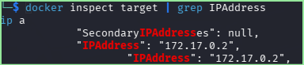
Target IP ^
Kali IP: 192.168.226.194

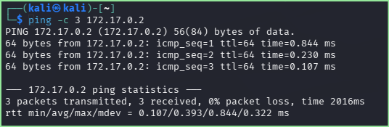
Successful Connection
Linux Persistence
- Attempt to safely simulate persistence. Refer to the slide deck for some examples and modify them.
  - Bind shell
    - If using Ubuntu I recommend installing netcat-traditional instead of netcat-openbsd
    - Insert screenshot showing attack

Bind Shell Attack

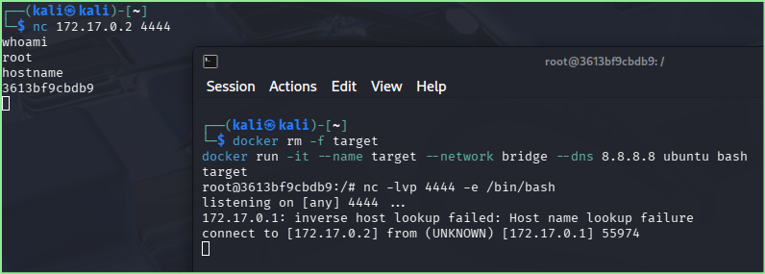
    - Find indicator of attack (Log… etc.)

Bind Shell Attack Indicator
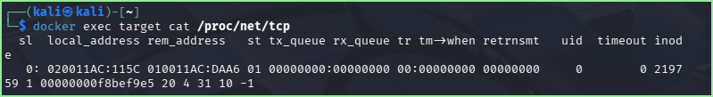

  - Reverse shell
    - Insert screenshot showing attack

Reverse Shell Attack

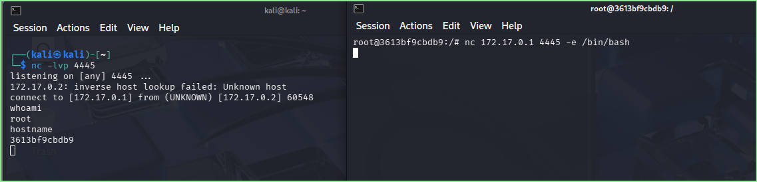

    - Find indicator of attack

Reverse Shell Attack Indicator

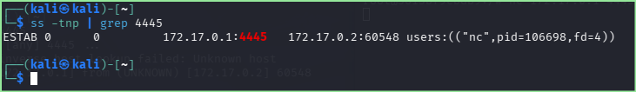

  - Web shell
    - Put your .php file into /var/www/html
<?php
// SAFE web-shell simulation for student lab
// Does NOT execute system commands

date_default_timezone_set('UTC');

$logfile = '/tmp/web_diagnostics.log';

// Log access
file_put_contents(
$logfile,
"[" . date("Y-m-d H:i:s") . "] Access from " . $_SERVER['REMOTE_ADDR'] . "\n",
FILE_APPEND
);

// Output basic diagnostic info
echo "<h2>Server Diagnostics</h2>";
echo "<pre>";
echo "Time: " . date("Y-m-d H:i:s") . "\n";
echo "Client IP: " . $_SERVER['REMOTE_ADDR'] . "\n";
echo "Request Method: " . $_SERVER['REQUEST_METHOD'] . "\n";
echo "Request URI: " . $_SERVER['REQUEST_URI'] . "\n\n";

echo "Received Parameters:\n";
print_r($_GET);
echo "</pre>";
?>
    - Access the safe file from browser http://<lab-server-ip>/lab_persist.php
    - Insert screenshot showing attack

Web Shell Attack

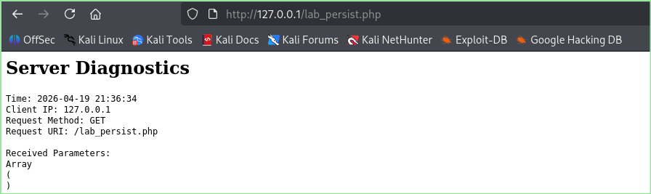

Find indicator of attack

Web Shell Attack Indicator

  - Cron / crontab
Checking Cron | Command
View cron persistence | crontab -l
Confirm execution artifact | cat lab_cron_test.log
Detect via logs | journalctl | grep CRON
Verify timeline | stat lab_cron_test.log
Enumerate other cron jobs | ls /etc/cron.*
Cleanup | crontab -e
    - Set your task to run every 2 minutes
    - Insert screenshot showing attack

Cron/Crontab Attack

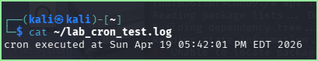

    - Find indicator of attack

Cron/Crontab Indicator

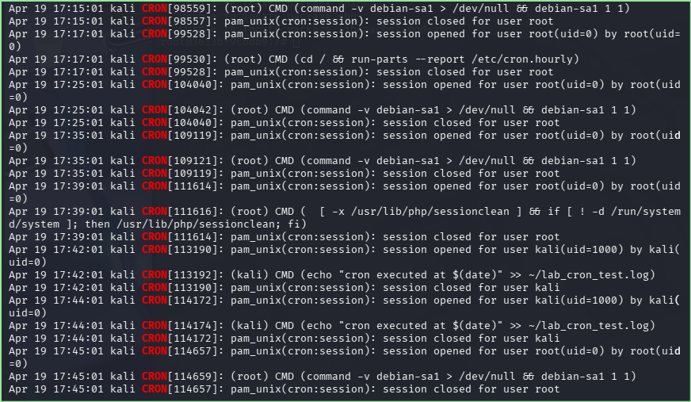

  - Panix Tool
    - Install the tool and attempt one attack method
      - Explain why you selected this persistence attack
      - Running commands is a single line. It is not a wizard.
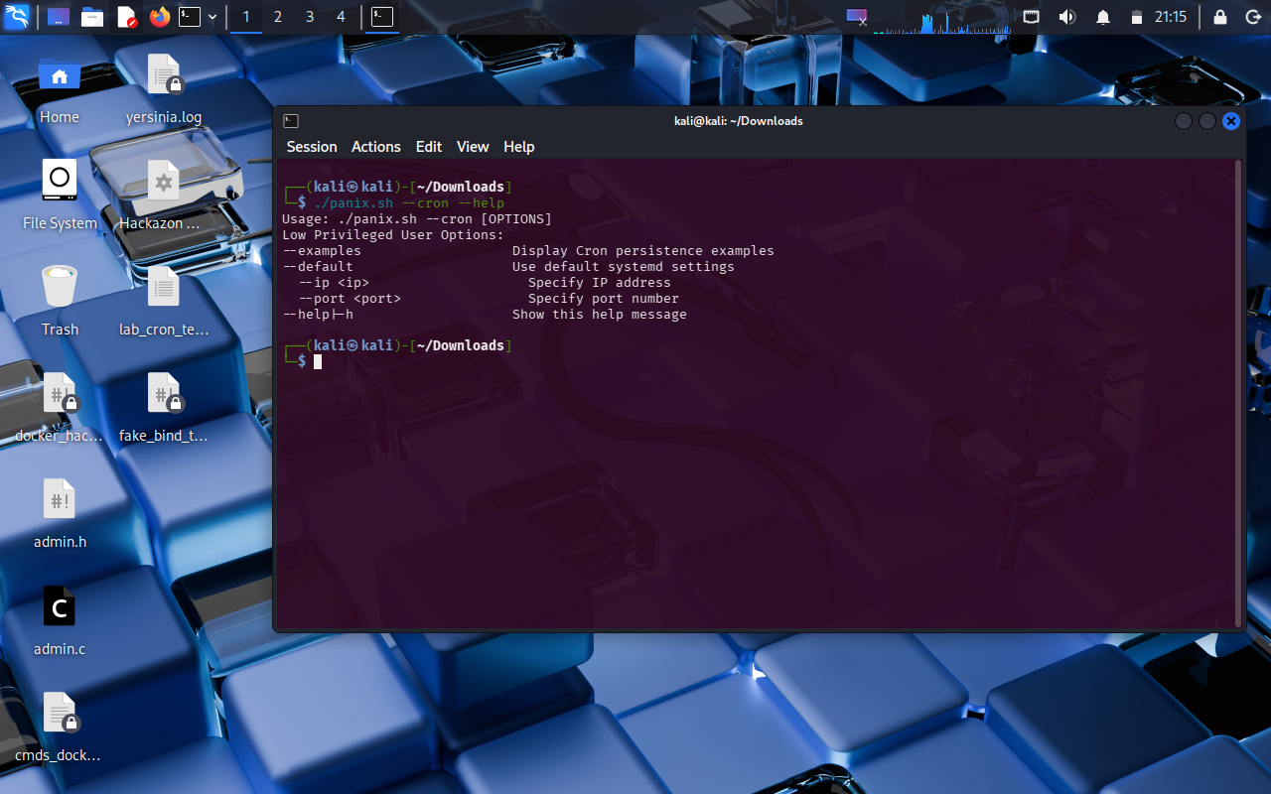

Using panix’s help menu, I choose to use --systemd to add system persistence.

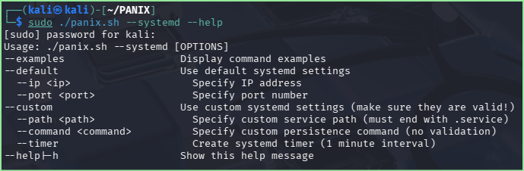
^Self reference

    - Insert screenshot showing attack

Panix Tool Attack

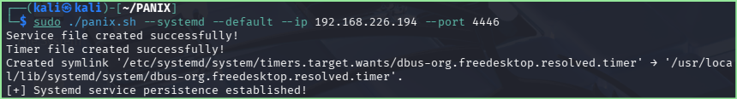

    - Find indicator of attack

Panix Tool Attack Indicator

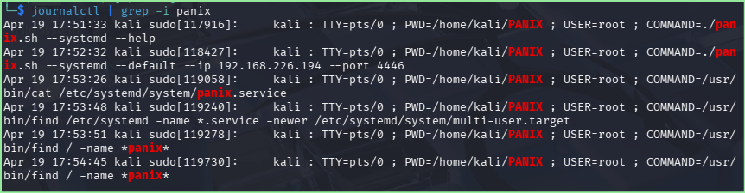

Persistence Type | Safe Trigger | What Appears in Logs / Files | Detection Focus
User Startup Scripts | Add a test echo/log action to shell init files | Modified .bashrc, .profile | User logon-triggered execution
Scheduled Jobs | Create a cron job that writes timestamps | Crontab entries, cron logs | New scheduled execution
systemd Services | Create a test service that logs start time | New service file, journal logs | New persistent system service
Environment Modification | Add a harmless environment variable | Shell config changes | Unexpected user config change

Linux Lateral Movement
- VMs or container should on the same network with connectivity
  - Insert screenshot

Lateral Movement Attack Linux

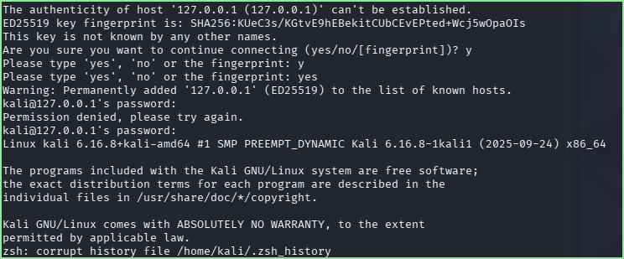

For the lateral movement section my goal was to simulate the reuse of credentials between two DIFFERENT hosts. I was having trouble getting Ubuntu to use SSH client tools so instead I showed SSHing into kali by using the command ssh kali@127.0.0.1.

Technique | Safe Trigger | Detection Signal
Credential Reuse | Same user logs into both VMs within short time | SSH auth logs, login timestamps
Unusual Source Pattern | Kali VM accesses other VM | Auth logs, service logs
Jump-Host Behavior | Kali VM keeps accessing other VM | Data volume, not exploit

Windows will be done in a future course… Skip Windows Persistence & Lateral Movement.
Windows Persistence
Persistence Type | Safe Trigger (What Students Do) | What Appears in Logs / Artifacts | What Students Should Detect
Startup Execution | Place a harmless script that writes to a text file at logon | File execution at user logon, startup folder entry | Unexpected execution at login time
Scheduled Task | Create a clearly named task that runs a benign script | Task creation events, task run history | Newly created scheduled task
Service Installation | Install a test service that writes “Service Started” to a file | Service install logs, service registry entry | New auto-start service
Registry Autostart | Add lab registry entry that runs a test binary | Registry modification logs | Registry autorun change

Windows Lateral Movement
Technique | Safe Trigger | Detection Signal
Remote Login | Authorized login between systems | Logon events across hosts
Service Access | Legitimate remote service use | Service access logs
Shared Credential Login | Same test account used widely | Account behavior anomalies

References

https://docs.docker.com/engine/network/drivers/bridge/

https://manpages.debian.org/bookworm/netcat-traditional/nc.traditional.1.en.html

